**#FunTimesWithTheTA   
The GoodNightLight: A Simple Nightlight Circuit**

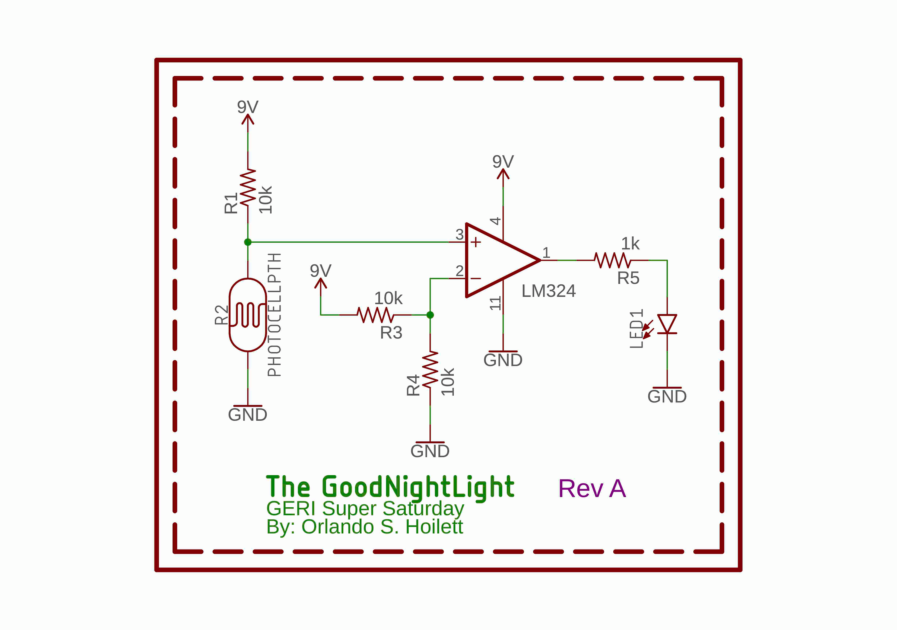

**Introduction**

In this installment of #FunTimesWithTheTA, we will build “The GoodNightLight: A Simple Nightlight Circuit”. The GoodNightLight will demonstrate a well-known mechanism where we are able to turn on a light when ambient light levels are low and turn the light off when ambient light levels increase. We will do so with a simple *comparator* circuit, a *photoresistor*, and an *LED* (light-emitting diode).

*Figure 1: Circuit diagram of The GoodNightLight.*

**Learning Objectives**

1. Become familiar with the basic electronic tools and measurement devices in the laboratory to measure voltages and currents.
2. Be able to construct a circuit from a schematic diagram.
3. Examine the basic behavior of comparators
4. Examine the basic behavior of photoresistors
5. Create a nightlight circuit that turns on an LED when it gets dark and turns the LED off when it gets bright

**ABET Outcomes**

“an ability to function effectively on a team whose members together provide leadership, create a collaborative and inclusive environment, establish goals, plan tasks, and meet objectives” (Outcome 5)

“an ability to develop and conduct appropriate experimentation, analyze and interpret data, and use engineering judgment to draw conclusions” (Outcome 6)

“an ability to acquire and apply new knowledge as needed, using appropriate learning strategies.” (Outcome 7)

http://www.abet.org/accreditation/accreditation-criteria/criteria-for-accrediting-

engineering-programs-2018-2019/

**Table of Contents**

|  |  |
| --- | --- |
| **Section** | **Page** |
| Introduction | **1** |
| Learning Objectives | **1** |
| ABET Outcomes | **1** |
| Key Terms and Definitions | **2** |
| Link to Tutorial | **3** |
| Revision History | **4** |

**Key Terms and Definitions**

***Photoresistor***

A sensor that changes resistance based on the incident light intensity. Also called light-dependent resistor (LDR) or photocell.

***Diode***

A type of circuit component that allows current to flow in one direction, but not the other.

***Light-Emitting Diode (LED)***

A special type of diode that emits light when current is flown through it.

***Voltage Divider***

A resistor network where two resistors are placed in series so that the input voltage is split between the two resistors.

***Single Supply***

A type of powering scheme that uses a single positive voltage compared to a reference point (ground) compared to using a positive and a negative voltage compared to a reference point. Think of this like a battery. Using a single battery, one, without any modification at least, has access to a reference point, the minus terminal of the battery, and the positive side of the battery. Single supply may also be referred to as “unipolar”.

***Operational Amplifier or Op Amp***

A type of circuit component that can perform mathematical operations on electrical signals such as multiplication, division, logarithm, etc.

***Comparator***

A type of op amp configuration that compares two voltages and outputs a given logic level based on the voltages at the input pins of the op amp.

**The rest of the instructions are located on an online “How-To” website.**

Please follow the link to see the rest of the instructions:

**Instructables Link:**

https://www.instructables.com/id/The-GoodNightLight-a-Simple-Nightlight-Circuit/

**Revision History**

|  |  |  |
| --- | --- | --- |
| **Revision Code** | **Revision**  **Date** | **Description** |
| A | 9/11/2018 | * Initial document for building the GoodNightLight by adding an introduction, learning objectives, ABET outcomes, key terms list, and a link to the Instructables page |